SCHOOL-WIDE EXPECTATIONS ↓ | Hallway Expectations
Respect Myself, Others and Property | - Students will follow directions first time.  - Voice level 0 when walking with class. 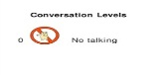  - Respond appropriately to adults when spoken to.
Aim High to Succeed | - Move with purpose and direction.  - Be attentive
Make safe and positive choices | - Walk on right side of hallway.  - Keep hands to self.  - Stop at designated areas.
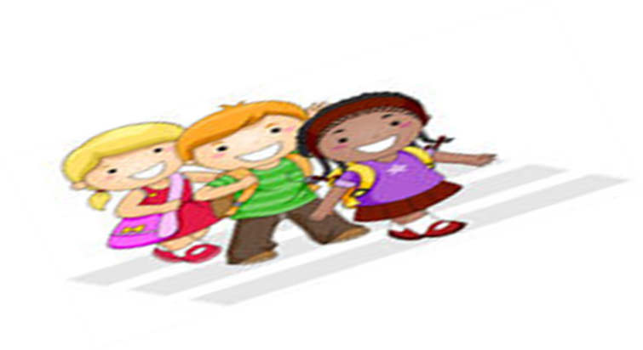  Show Integrity | - Keep hallways free of trash.  - Right place at the right time

